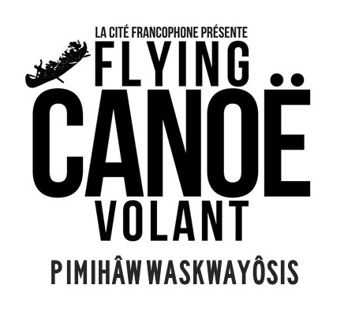
CALL FOR ARTISTS
Festival dates: January 30 to February 1, 2020
Deadline for submissions is Jan. 6, 2020
We will reply with your acceptance status by Jan. 8th
Site walk to view and choose your location will be determined in Jan.
Celebrating on Treaty 6 land, Flying Canoë Volant is a free, family- friendly, evening winter festival that embraces and promotes Canada’s founding Indigenous, Métis and Francophone cultures. Within shared and inclusive spaces, we see the legend of Flying Canoë Volant come alive through illuminated sculptures, music, dance, food, winter activities and so much more. The festival is always striving to bring out the best in its communities by creating joy, intrigue and a little winter magic.
Flying Canoë Volant is currently accepting applications for illuminated installations to be located in the Mill Creek Ravine along the festival trails. For further information about Flying Canoë Volant and submission requirements please contact Visual Art Programming Coordinator Lynette Maurice by email at lynettemaurice@shaw.ca
GUIDELINES:
Projects will be installed along the festival path in the Mill Creek Ravine on January 28-29 and will be fully operational from 6-10pm on January 30, 31 and February 1. All projects must be prepared for inclement and changeable winter weather conditions. There is limited access to power sources and installation plans should consider using batteries and alternate energy sources. If accepted, projects must be installed and exhibited in a safe manner and dismantled February 2, leaving no impact on the installation site. All projects should be light based installations that work with the Festival’s sense of winter magic and wonder in the wooded environment.

Accepted projects will benefit from high public visibility - approx. 35,000 patrons in 2019 - a fee of $1000 includes artist fees and materials is provided as is assistance with power and security where possible.

APPLICATION:
Submissions are to be submitted electronically, to lynettemaurice@shaw.ca . Please send the following documents in PDF with the exception of images which need to be sent in JPEG form:
1) Completed section A and B in table below
2) Project description
3) Brief artist Bio and Curriculum Vitae
4) Up to 6 supporting images in JPEG form, no larger than 1 MB per file (prior work or project sketches)
5) Detailed image list corresponding to images submitted

Section A: Artist Information
First and last name

Primary phone number

Email Address

Mailing Address

Preferred Method of contact

Names of collaborators/participating organization

Website or Social Media Handles as applicable

Section B: Project Information
Project Title

Project Description (maximum 500 words) Please attach a separate sheet labeled “Project Description.”
This document should include the following items:
1. Detailed description​of the project,
2.Technical proposal​, including installation and de-installation plan, timeline, location, materials and equipment, collaborators, possible safety concerns, needs for power or installation supports, etc.…
3. Site information, or discussion of ideal conditions of viewership, especially in terms of location (e.g. “The project is projected onto a screen and needs power to run projection and space to be viewable from a distance”, or “The installation needs to be in a dark area and suspended from a large tree”, etc.)
All applicants will be notified of the result of their application.
For further information about Flying Canoë Volant and submission requirements please contact the Visual Art Programming Coordinator Lynette Maurice by email at lynettemaurice@shaw.ca
Deadline for Submission is January 6, 2020

